**Name: Sai kiran J**

**Email:** [**Saikiranj2002@gmail.com**](mailto:Saikiranj2002@gmail.com)

**PowerBI:** [**https://drive.google.com/file/d/1C2TeUnr36B9p148E2e9CTmu1h3yOOJg-/view?usp=sharing**](https://drive.google.com/file/d/1C2TeUnr36B9p148E2e9CTmu1h3yOOJg-/view?usp=sharing)

**1. Walmart Sales Analysis: You have been given a data set to analyse and answer the following questions: Candidate can answer the questions by using any technical tool (Excel, Sheets, Python, etc..) Data Set: Walmart Sales [Kindly find an attached copy in the email]**

* **A. Analyse the performance of sales and revenue at the city and branch level ( 5 marks)**
* **B. What is the average price of an item sold at each branch of the city (10 marks)**
* **C. Analyze the performance of sales and revenue, Month over Month across the Product line, Gender, and Payment Method, and identify the focus areas to get better sales for April 2019. (15 marks)**

**A. Analyse the performance of sales and revenue at the city and branch level ( 5 marks**)

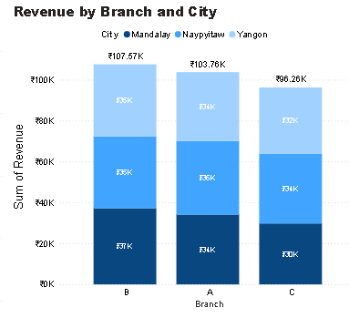

**City: Mandalay**

* Branch A: Revenue generated is 34,130.09 Kyat.
* Branch B: Revenue generated is 37,215.93 Kyat (Highest).
* Branch C: Revenue generated is 24,794.62 Kyat.

**City: Naypyitaw**

* Branch A: Revenue generated is 35,985.64 Kyat (Highest).
* Branch B: Revenue generated is 35,157.75 Kyat.
* Branch C: Revenue generated is 34,160.14 Kyat.

**City: Yangon**

* Branch A: Revenue generated is 33,647.26 Kyat.
* Branch B: Revenue generated is 35,193.51 Kyat (Highest).
* Branch C: Revenue generated is 32,302.43 Kyat.

**Total Revenue Across Cities by Branch:**

* Branch A: 103,763 Kyat
* Branch B: 107,567.19 Kyat (Highest).
* Branch C: 96,257.19 Kyat

**Key Insights:**

1. In Mandalay, Branch B generated the highest revenue.

2. In Naypyitaw, Branch A generated the highest revenue.

3. In Yangon, Branch B generated the highest revenue.

4. Across all cities, Branch B performed the best in terms of total revenue.

**B. What is the average price of an item sold at each branch of the city (10 marks)**

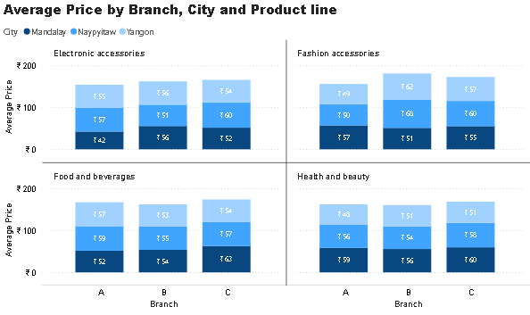

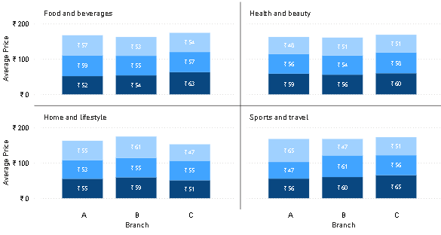

**City: Mandalay**

**Branch A:**

* Electronic Accessories: 42 Kyat
* Fashion Accessories: 55 Kyat
* Food and Beverages: 60 Kyat
* Health and Beauty: 50 Kyat
* Home and Lifestyle: 52 Kyat
* Sports and Travel: 47 Kyat

**Branch B**:

* Electronic Accessories: 48 Kyat
* Fashion Accessories: 55 Kyat
* Food and Beverages: 60 Kyat
* Health and Beauty: 55 Kyat
* Home and Lifestyle: 60 Kyat
* Sports and Travel: 52 Kyat

Branch C:

* Electronic Accessories: 52 Kyat
* Fashion Accessories: 60 Kyat
* Food and Beverages: 63 Kyat
* Health and Beauty: 60 Kyat
* Home and Lifestyle: 58 Kyat
* Sports and Travel: 65 Kyat

**City: Naypyitaw**

Branch A:

* Electronic Accessories: 50 Kyat
* Fashion Accessories: 60 Kyat
* Food and Beverages: 55 Kyat
* Health and Beauty: 58 Kyat
* Home and Lifestyle: 53 Kyat
* Sports and Travel: 47 Kyat

Branch B:

* Electronic Accessories: 55 Kyat
* Fashion Accessories: 68 Kyat
* Food and Beverages: 60 Kyat
* Health and Beauty: 60 Kyat
* Home and Lifestyle: 55 Kyat
* Sports and Travel: 60 Kyat

Branch C:

* Electronic Accessories: 60 Kyat
* Fashion Accessories: 65 Kyat
* Food and Beverages: 62 Kyat
* Health and Beauty: 60 Kyat
* Home and Lifestyle: 60 Kyat
* Sports and Travel: 63 Kyat

**City: Yangon**

Branch A:

* Electronic Accessories: 45 Kyat
* Fashion Accessories: 49 Kyat
* Food and Beverages: 55 Kyat
* Health and Beauty: 48 Kyat
* Home and Lifestyle: 50 Kyat
* Sports and Travel: 47 Kyat

Branch B:

* Electronic Accessories: 50 Kyat
* Fashion Accessories: 55 Kyat
* Food and Beverages: 60 Kyat
* Health and Beauty: 53 Kyat
* Home and Lifestyle: 61 Kyat
* Sports and Travel: 50 Kyat

Branch C:

* Electronic Accessories: 48 Kyat
* Fashion Accessories: 52 Kyat
* Food and Beverages: 50 Kyat
* Health and Beauty: 52 Kyat
* Home and Lifestyle: 55 Kyat
* Sports and Travel: 47 Kyat

**Key Insights**

**1. Electronics Accessories**

The highest average price for electronic accessories is 60 Kyat at Branch C in Naypyitaw, while the lowest is 42 Kyat at Branch A in Mandalay.

**2. Fashion Accessories**

The highest average price for fashion accessories is 68 Kyat at Branch B in Naypyitaw, with the lowest at 49 Kyat at Branch A in Yangon.

**3. Food and Beverages**

The highest average price for food and beverages is 63 Kyat at Branch C in Mandalay, while the lowest is 52 Kyat at Branch A in Mandalay.

**4. Health and Beauty**

The highest average price for health and beauty items is 60 Kyat at Branch C in Mandalay, and the lowest is 47 Kyat at Branch A in Yangon.

**5. Home and Lifestyle**

The highest average price for home and lifestyle products is 61 Kyat at Branch B in Yangon, while the lowest is 47 Kyat at Branch C in Yangon.

**6. Sports and Travel**

The highest average price for sports and travel is 65 Kyat at Branch C in Mandalay, while the lowest is 47 Kyat at both Branch B in Naypyitaw and Branch C in Yangon.

**C. Analyze the performance of sales and revenue, Month over Month across the Product line, Gender, and Payment Method, and identify the focus areas to get better sales for April 2019. (15 marks)**

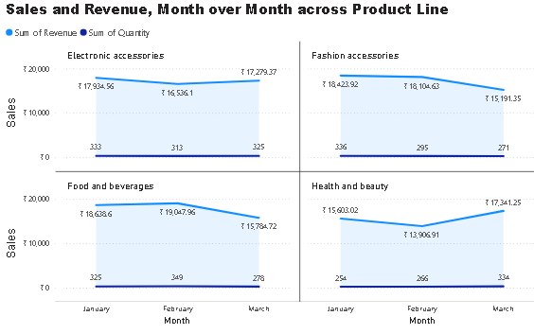

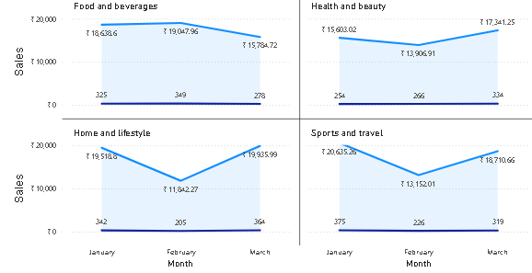

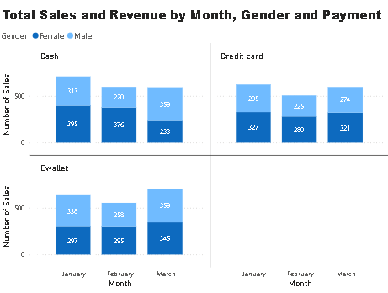

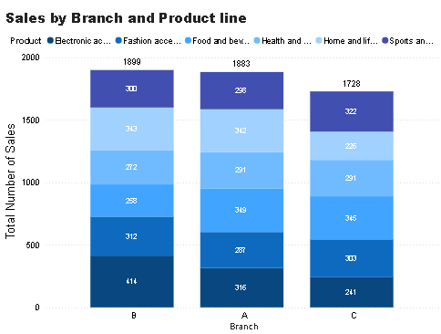

**Mandalay City**

**Branch A:**

* Total Revenue: 9.7k Kyat
* Revenue Trend: Decreased from 13.6k Kyat (January) to 9.7k Kyat (March)
* Top Sales Categories:
* Male: Home and Lifestyle
* Female: Health and Beauty
* Least Popular Products:
* Men: Electronic Accessories
* Women: Sports and Travel
* Payment Methods:
* Most Used: E-Wallet
* Second Most Used: Cash and Credit Card

**Insight:**

Health and Beauty, along with Home and Lifestyle, are the best-selling categories in Branch A. To boost sales, consider running exclusive offers and targeted promotions for these top categories. Keep an eye on inventory trends to ensure you always have the popular items in stock.

**Branch B:**

* Total Revenue: 9.5k Kyat
* Revenue Trend: Decreased from 15k Kyat (February) to 9.5k Kyat (March)
* Top Sales Categories:
* Male: Health and Beauty
* Female: Home and Lifestyle
* Least Popular Products:
* Men: Food and Beverages
* Women: Health and Beauty
* Payment Methods:
* Equal distribution across Cash, E-Wallet, and Credit Card

**Insight:**The drop in revenue from February to March indicates a potential market shift. It might be helpful to focus on promotional strategies for the less popular categories like Food and Beverages (for men) and Health and Beauty (for women) to recover the lost sales.

**Branch C:**

* Total Revenue: 13.7k Kyat
* Revenue Trend: Increased from 9.2k Kyat (January) to 13k Kyat (March)
* Top Sales Categories:
* Male: Sports and Travel
* Female: Home and Lifestyle
* Least Popular Products:
* Men: Electronic Accessories
* Women: Health and Beauty
* Payment Methods:
* Most Used: Credit Card
* Second Most Used: E-Wallet

**Insight:** Branch C has shown a positive revenue trend. Continuing promotions for top-performing categories like Sports and Travel can help maintain this momentum. Additionally, addressing the underperforming categories such as Electronic Accessories and Health and Beauty for both genders could drive further growth.

**Naypyidaw City**

**Branch A:**

* Total Revenue: 12.4k Kyat
* Revenue Trend: Decreased from 14.5k Kyat (January) to 9.1k Kyat (February) and then increased to 12.4k Kyat in March
* Top Sales Categories:
* Male: Home and Lifestyle
* Female: Health and Beauty
* Least Popular Products:
* Men: Sports and Travel
* Women: Sports and Travel
* Payment Methods:
* Most Used: Cash
* Second Most Used: E-Wallet

**Insight:** Home and Lifestyle and Health and Beauty are the top-performing categories in Branch A. To boost sales further, consider running exclusive offers on these categories. Also, focus on improving sales in the underperforming Sports and Travel segment for both genders.

**Branch B:**

* Total Revenue: 35.2k Kyat
* Revenue Trend: Stable (12.4k Kyat in January and 12.2k Kyat in February)
* Top Sales Categories:
* Male: Home and Lifestyle
* Female: Health and Beauty
* Least Popular Products:
* Men: Sports and Travel
* Women: Sports and Travel
* Payment Methods:
* Most Used: Cash
* Second Most Used: E-Wallet

**Insight:** Branch B has maintained a stable revenue, indicating a steady market presence. To improve sales further, consider consistent promotional efforts targeting the less popular Sports and Travel category for both genders.

**Branch C:**

* Total Revenue: 34.2k Kyat
* Revenue Trend: Increased from 9.2k Kyat (January) to 13k Kyat (March)
* Top Sales Categories:
* Male: Electronics
* Female: Home and Lifestyle
* Least Popular Products:
* Men: Food and Beverages
* Women: Electronic Accessories
* Payment Methods:
* Most Used: Cash
* Second Most Used: E-Wallet

**Insight:** Electronics and Home and Lifestyle are the highest-performing categories in Branch C. To continue the positive trend, maintaining promotions for these successful categories is crucial. Also, focus on boosting sales in the less popular categories like Food and Beverages for men and Electronic Accessories for women.

**Yangon City**

**Branch A:**

* Total Revenue: 33.6k Kyat
* Revenue Trend: Increased from 10.1k Kyat (January) to 13.3k Kyat (March)
* Top Sales Categories:
* Male: Health and Beauty
* Female: Home and Lifestyle
* Least Popular Products:
* Men: Fashion Accessories
* Women: Health and Beauty
* Payment Methods:
* Most Used: E-Wallet
* Second Most Used: Credit Card

**Insight:**  Health and Beauty products perform well for both men and women in Branch A. To drive sales further, consider targeted marketing efforts for Sports and Travel categories for both genders and Fashion Accessories for men.

**Branch B:**

* Total Revenue: 35.2k Kyat
* Revenue Trend: Fluctuated (15k Kyat in January, 7.9k Kyat in February, and 12.3k Kyat in March)
* Top Sales Categories:
* Male: Electronic Accessories
* Female: Health and Beauty
* Least Popular Products:
* Men: Health and Beauty
* Women: Food and Beverages
* Payment Methods:
* Most Used: Cash
* Second Most Used: E-Wallet

**Insight:** Electronic Accessories perform well in Branch B, while Food and Beverages underperform for both genders. Targeted promotions focusing on these categories could help bridge the sales gap and stabilize the revenue trend.

**Branch C:**

* Total Revenue: 32.3k Kyat
* Revenue Trend: Slight decrease from 11.7k Kyat (January) to 10.2k Kyat (March)
* Top Sales Categories:
* Male: Sports and Travel
* Female: Sports and Travel
* Least Popular Products:
* Men: Fashion Accessories
* Women: Home and Lifestyle
* Payment Methods:
* Most Used: E-Wallet
* Second Most Used: Credit Card

**Insight:**  Sports and Travel products perform strongly in Branch C. To maintain this trend, continue promoting these categories while focusing on improving sales for less popular items like Fashion Accessories and Home and Lifestyle.

**2. App Exploration: (5 marks) Explore the features and user experience of the Jar app. Identify two aspects that you think could be significantly improved and explain your reasoning behind each suggestion.**

**1.** **Feature Improvement:** Claiming rewards from spins or games feels complicated and not very exciting for users.

**Solution:** Bring a Jar Wallet — a special area where all the reward points and winnings are stored.

**How It Works:**

- Points from games like spins go into the Jar Wallet.

- These points can be used for:

1. Buying gold in the Jar app.

2. Shopping at Nek (the jewellery store).

**Benefits:** Makes using rewards easier and more enjoyable for users.

Transforms rewards into something that carries real value and meaning, linked to tangible savings or investments.

Creates a coherent and captivating experience with the tagline “Spin, Save, and Shine!”.

**2.** **Feature Improvement:** People do not understand how to set their objectives and also do not have a clear vision to reach them, thus setting poor goals.

**Solution:** Allow users to establish in-depth savings targets (I want to save so much money for a bicycle, let’s say Rupee One lakh).

**How It Works:**

- Users provide an approximate picture of how much they wish to save and what the purpose is “e.g., ‘I want to save ₹1,00,000 to buy a bike’” .

- The Jar application aids users by sending notification messages which creates a possible urge for the user to achieve certain goals, using milestones.

- Wording in the message suggests that the amount of money saved for some time is increasing in gold and is beneficial in the long run.

**Benefits:**

- It can help users to build a better financial model about how they couch saving i.e. as an investment to grow money in gold.

- Enhances anticipation with ‘You're almost there. Just save a little more – for your dream bike’ type messages.

- After all aspirations are achieved Jar will be presented as a friends while at the same time gold will be promoted as a best investment.

**3.** **Feature Improvement:** A few clients do spend their Jar savings when transacting at Nek. The app takes everything by default which can lead to a situation where the money saved for specific goal achievements on Jar is utilized in purchasing stuff on Nek, and thus destroying other priorities.

**Solution:** A feature enhancement to allow goal setting or give users the option on how much of their Jar savings they want to spend on purchasing items from Nek.

**How It Works:**

- Create a slider or bar where users can choose what percentage of their Jar savings should be used for purchases on Nek. (20%, 30, and so on).

- Present a tick box and make it mandatory such that the box is clicked before any action is taken to burn funds.

- Emphasize that while making purchases, some users can choose to set their goals first.

**Benefits:**

- Avoids situations where users may exhaust funds on one single item although the aim is not to.

- Provides an avenue where users can appropriately redistribute the fund across several needs.

- Makes it clear on what topics spending is on to achieve and improving the objectives.

**Example Notification:** “You’re transferring 30% of your Jar balance to buy this product. Please tap to approve!”

**4.Feature Improvement**: The application provides users with trends displaying the gold price for overdue timelines but users are lacking sufficient amounts of *real time updates* in regards to price movements to aid in quick investment.

**Solution:** Users should be able to receive gold price notifications in order to maximize their earning potential whenever a precious metal can be purchased.

**How It Works:**

- Send alerts whenever the gold price falls below a certain level within the day.

- Include a brief statement articulating the reasons why it is a good time to make an investment.

**Benefits:**

- Timely investments are made by the users which allows them to invest at the right times.

- Shows active assistance in clients maximizing their savings which builds trust in followers of Jar.

- Promotes investment in gold consistently making it a dependable option.

**Example Notification:** “Gold prices have today gone down by ₹200! Make an investment today to benefit from your savings.”.

**3. Product Optimisation: (5 marks) The Jar app has an engagement feature called 'Spin to Win'. Right now, if 100 people come to the app each day, only 23 of them try out this spinning game. But, we know that people who spin are more likely to retain on the app and do transactions. Now, we want to get more people to play the game. So, the question is, how can we make sure that at least 50 people out of every 100 who visit the app each day will play 'Spin to Win'? What can we do to get more people interested in spinning the wheel?**

**Spin to Win Wheel Concept: “Spin, Earn Points and Buy Gold”**

- **Slots with Question Marks:** Few slots on the wheel will have a mystery ‘?’ as slot result which gives the user a mystery reward.

- **Gold as the Highlight:** All other slots will just show the rupees and how many gold grams Those rupees will help us get.

e.g. "₹10 = 0.01g of Gold"

"₹50 = 0.05g of Gold"

This straightforward connection of money to gold will hold users’ attention on gold as their primary motivation.

**Clear Goal:** Users can see how much gold they can purchase as they spin and earn points. The points are the currency to buy Gold and it makes it so real and exciting.